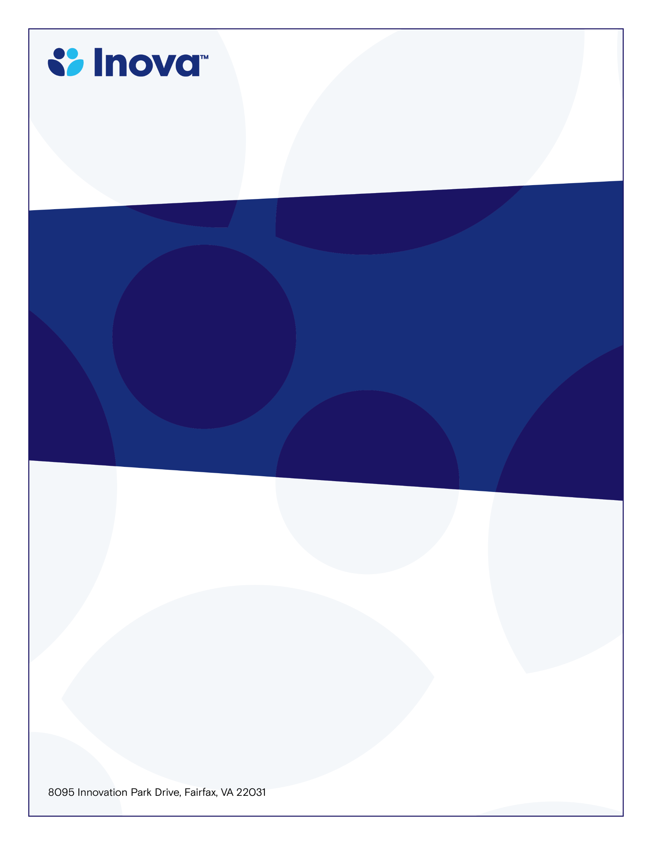
Perinatology Conference Series
Department of Maternal Fetal Medicine
Case Reviews: PV Stenosis with Suspected VSD
Katie Cooper, RDMS
Friday Location-Teams
July 10th, 2026 12pm – 1pm

12:30-1:30

November 14, 2023
12:30-1:30pm
Antenatal Testing Center

Learning Objectives
- Review both abnormalities
- Determine if imaging met diagnostic needs
- Sonographer Pearls
- Ultrasound machine settings that will aid in diagnosis
- Review critical thinking next-steps

Target Audience
Ultrasonographers, sonography students, OBGYN Residents, MFM Fellows
To claim credit, text code YAFRAS to 703-260-9391
Accreditation: The Inova Office of Continuing Medical Educations is accredited by the Medical Society of Virginia to provide continuing medical education for physicians.
Credit Designation: The Inova Office of Continuing Medical Education designates this live educational activity for a maximum of 1.0 AMA PRA Category 1 Credit(s)™. Physicians should only claim credit commensurate with the extent of their participation in the activity. Physicians may claim up to 1.0 credit in Type 1 CME on the Virginia Board of Medicine Continued Competency and Assessment Form required for renewal of an active medical license in Virginia.

