
Department of Medicine
Inova Fairfax Medicine Grand Rounds presents The Inova Dudley Family Center Visiting Professor Series

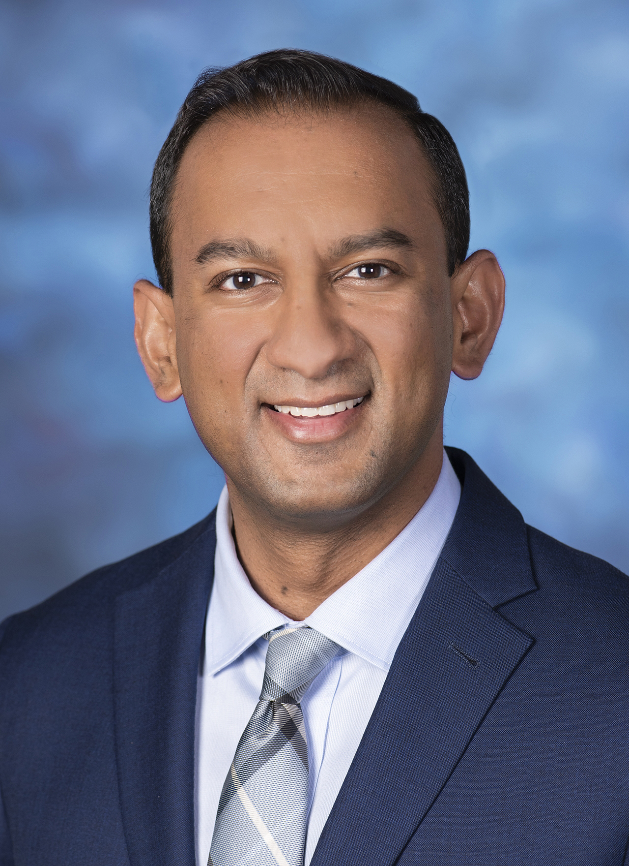

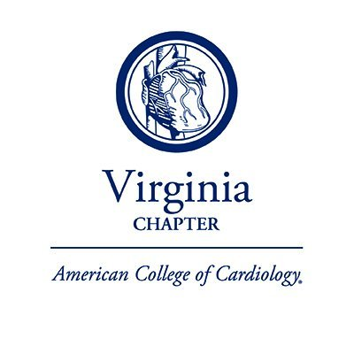
Target audience: Members of the medical staff all subspecialties, medical residents and students.
Learning objectives:
- Review the challenges in phenotyping and improving clinical outcomes in cardiogenic shock
- Examine a standardized team-based approach and regionalized network of care delivery for cardiogenic shock patients
- Explore novel opportunities for improvement in longitudinal wellbeing of cardiogenic shock survivors

Join online: Click here to join the meeting
Meeting ID: 256350575265 Password: DnoQXN
Or call in (audio only)
+1 571-307-5517,,481-664-296#
A Special Session
State-Wide Cardiology Grand Rounds
Evaluation and Management of Cardiogenic Shock in 2025
Shashank S. Sinha, MD, MSc, FACC, FAHA, FHFSA
Assistant Professor of Medical Education, University of Virginia School of Medicine
Medical Director, Cardiac Intensive Care Unit, Cardiology
Director, Cardiovascular Critical Care Research Program
Advanced Heart Failure, Mechanical Circulatory Support, and Transplant Cardiologist
Inova Schar Heart and Vascular, Inova Fairfax Medical Campus

Virtual: Teams
April 8, 2025
12:30pm – 1:30pm
To claim CME credit,
text FOVCOS
to 703.260.9391 or log into the CME website cme.inova.org
Accreditation: The Medical Society of Virginia is a member of the Southern States CME Collaborative, an ACCME Recognized Accreditor. Inova Health System Office of Continuing Medical Education is accredited by the Southern States CME Collaborative to provide continuing medical education for physicians.
Credit designation: The Inova Office of Continuing Medical Education designates this live educational activity for a maximum of 1.0 AMA PRA Category 1 Credit(s)™. Physicians should only claim credit commensurate with the extent of their participation in the activity. Physicians may claim up to 1.0 credit in Type 1 CME on the Virginia Board of Medicine Continued Competency and Assessment Form required for renewal of an active medical license in Virginia.

Inova.org

