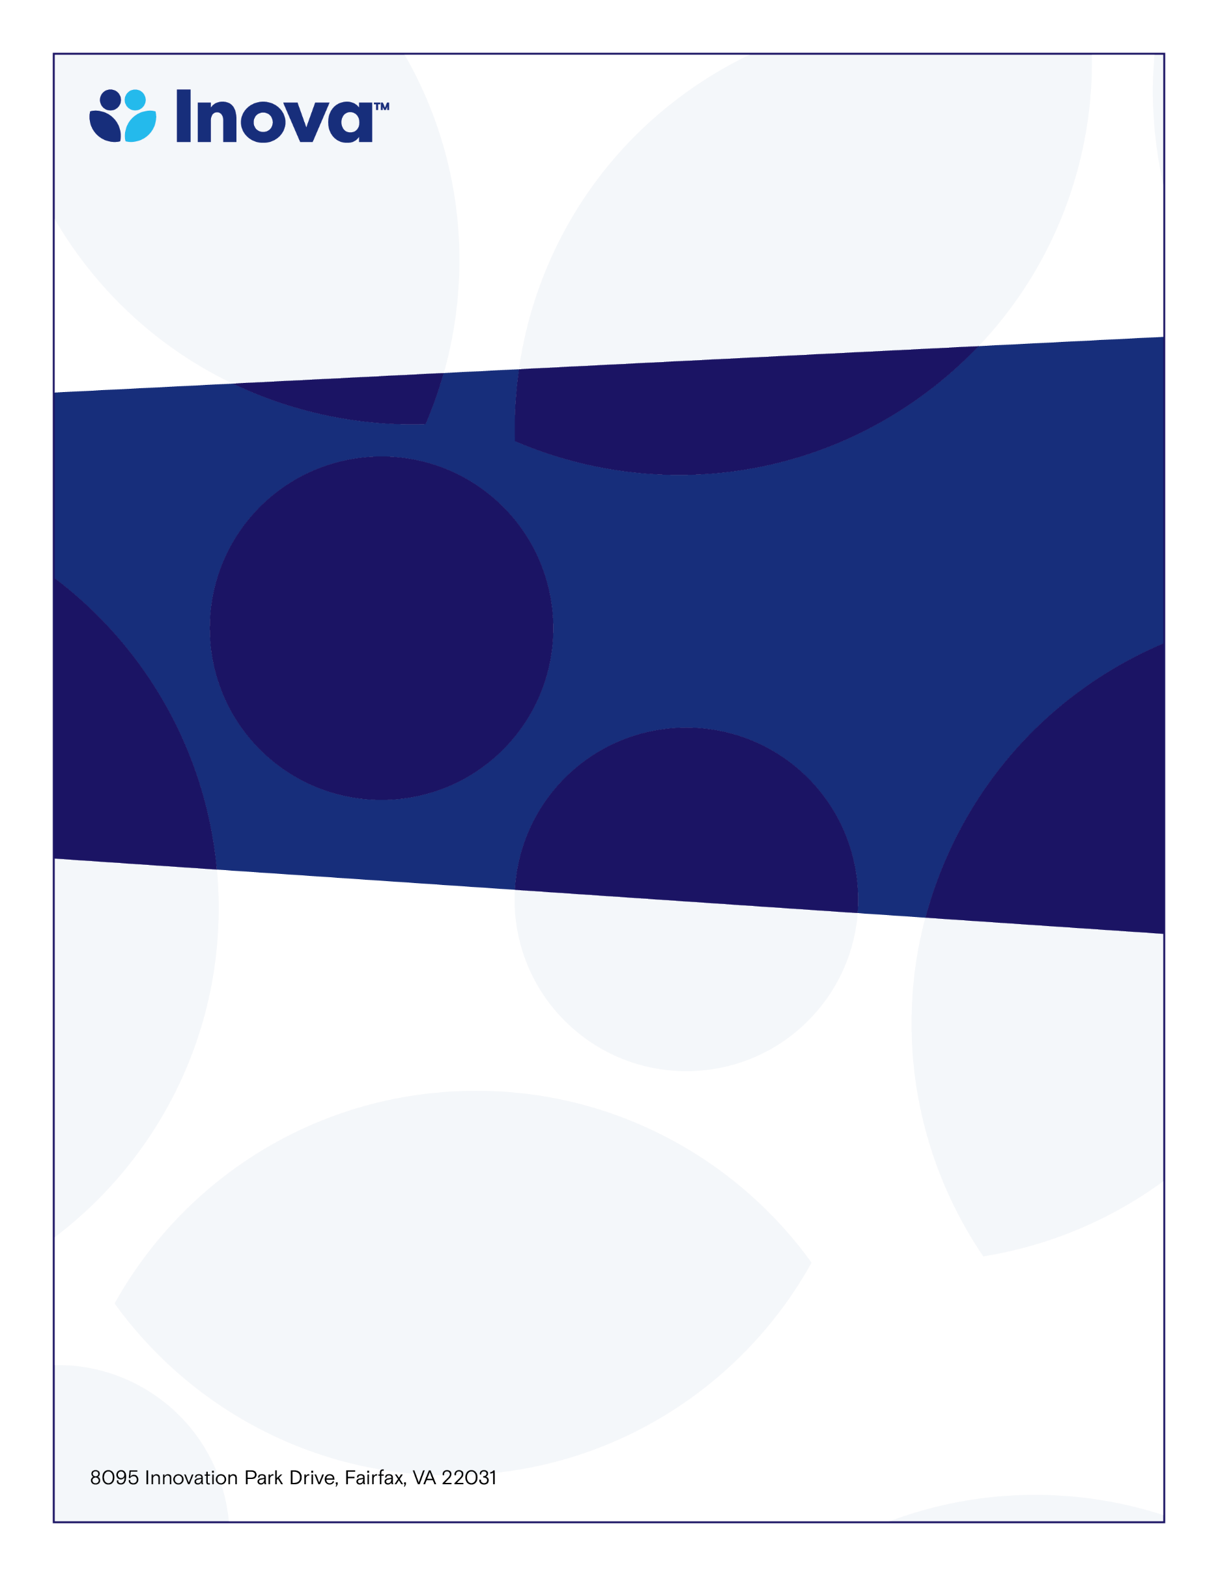

Perinatology Conference Series

Department of Maternal Fetal Medicine

Imaging Enhancement – Tips for the hard to image patient

Kathryn Cooper, RDMS

**Friday Location-Teams**

**September 20, 2024 7:30- 8:00 AM**

**12:30-1:30**

**November 14, 2023**

**12:30-1:30pm**

**Antenatal Testing Center**

**Learning Objectives**

* Utilizing 3D imaging
* Colorflow tips
* Penetration setting recommendations

**Target Audience**

Ultrasonographers, sonography students, OBGYN Residents, MFM Fellows

**To claim credit, text code VENFOY to 703-260-9391**

**Accreditation:** The Inova Office of Continuing Medical Educations is accredited by the Medical Society of Virginia to provide continuing medical education for physicians.

**Credit Designation:** The Inova Office of Continuing Medical Education designates this live educational activity for a maximum of 1.0 AMA PRA Category 1 Credit(s)™. Physicians should only claim credit commensurate with the extent of their participation in the activity. Physicians may claim up to 1.0 credit in Type 1 CME on the Virginia Board of Medicine Continued Competency and Assessment Form required for renewal of an active medical license in Virginia.