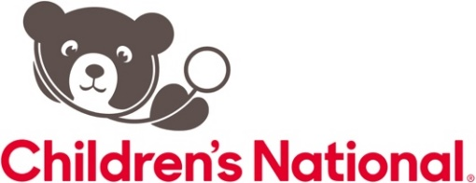

**Target audience:** Pediatric Pulmonologists; Advance Practice Practitioners, nurses and respiratory therapists in pulmonary medicine; Intensivists; Emergency Medicine physicians; Allergists; General Pediatricians

**Learning objectives:**

* **Discuss the microbiology epidemiology of cystic fibrosis**

* **Discuss antimicrobial susceptibility testing in cystic fibrosis**
* **Discuss the role of antibiotics in treatment of pulmonary exacerbations**

**Andrea Hahn, MD,**

Attending, Infectious Diseases Children’s National Hospital

Tenured Associate Professor of Pediatrics at George Washington Unoversity

**Leila and Irving Perlmutter Professor of Pediatrics, Harvard Medical School**

**Antibiotics in Patients with Cystic Fibrosis**

**Accreditation:** The Medical Society of Virginia is a member of the Southern States CME Collaborative, an ACCME Recognized Accreditor. This activity has been planned and implemented in accordance with the accreditation requirements and policies of the Southern States CME Collaborative (SSCC) through the joint providership of Inova Health System Office of Continuing Medical Education and Children’s National Hospital. Inova Health System Office of Continuing Medical Education is accredited by the SSCC to provide continuing medical education for physicians.

**Credit designation:** The Inova Office of Continuing Medical Education designates this live educational activity for a maximum of 1.0 AMA PRA Category 1 Credit(s)™. Physicians should only claim credit commensurate with the extent of their participation in the activity. Physicians may claim up to 1.0 credit in Type 1 CME on the Virginia Board of Medicine Continued Competency and Assessment Form required for renewal of an active medical license in Virginia.

**Pulmonary and Sleep Medicine Department**

**Virtual via ZOOM**

**August 23, 2024**

**8:00AM-9:00AM**

**To claim credit,   
text VATJOG  
to 703.260.9391**

**Pediatric Pulmonology: State-of-the-Art**