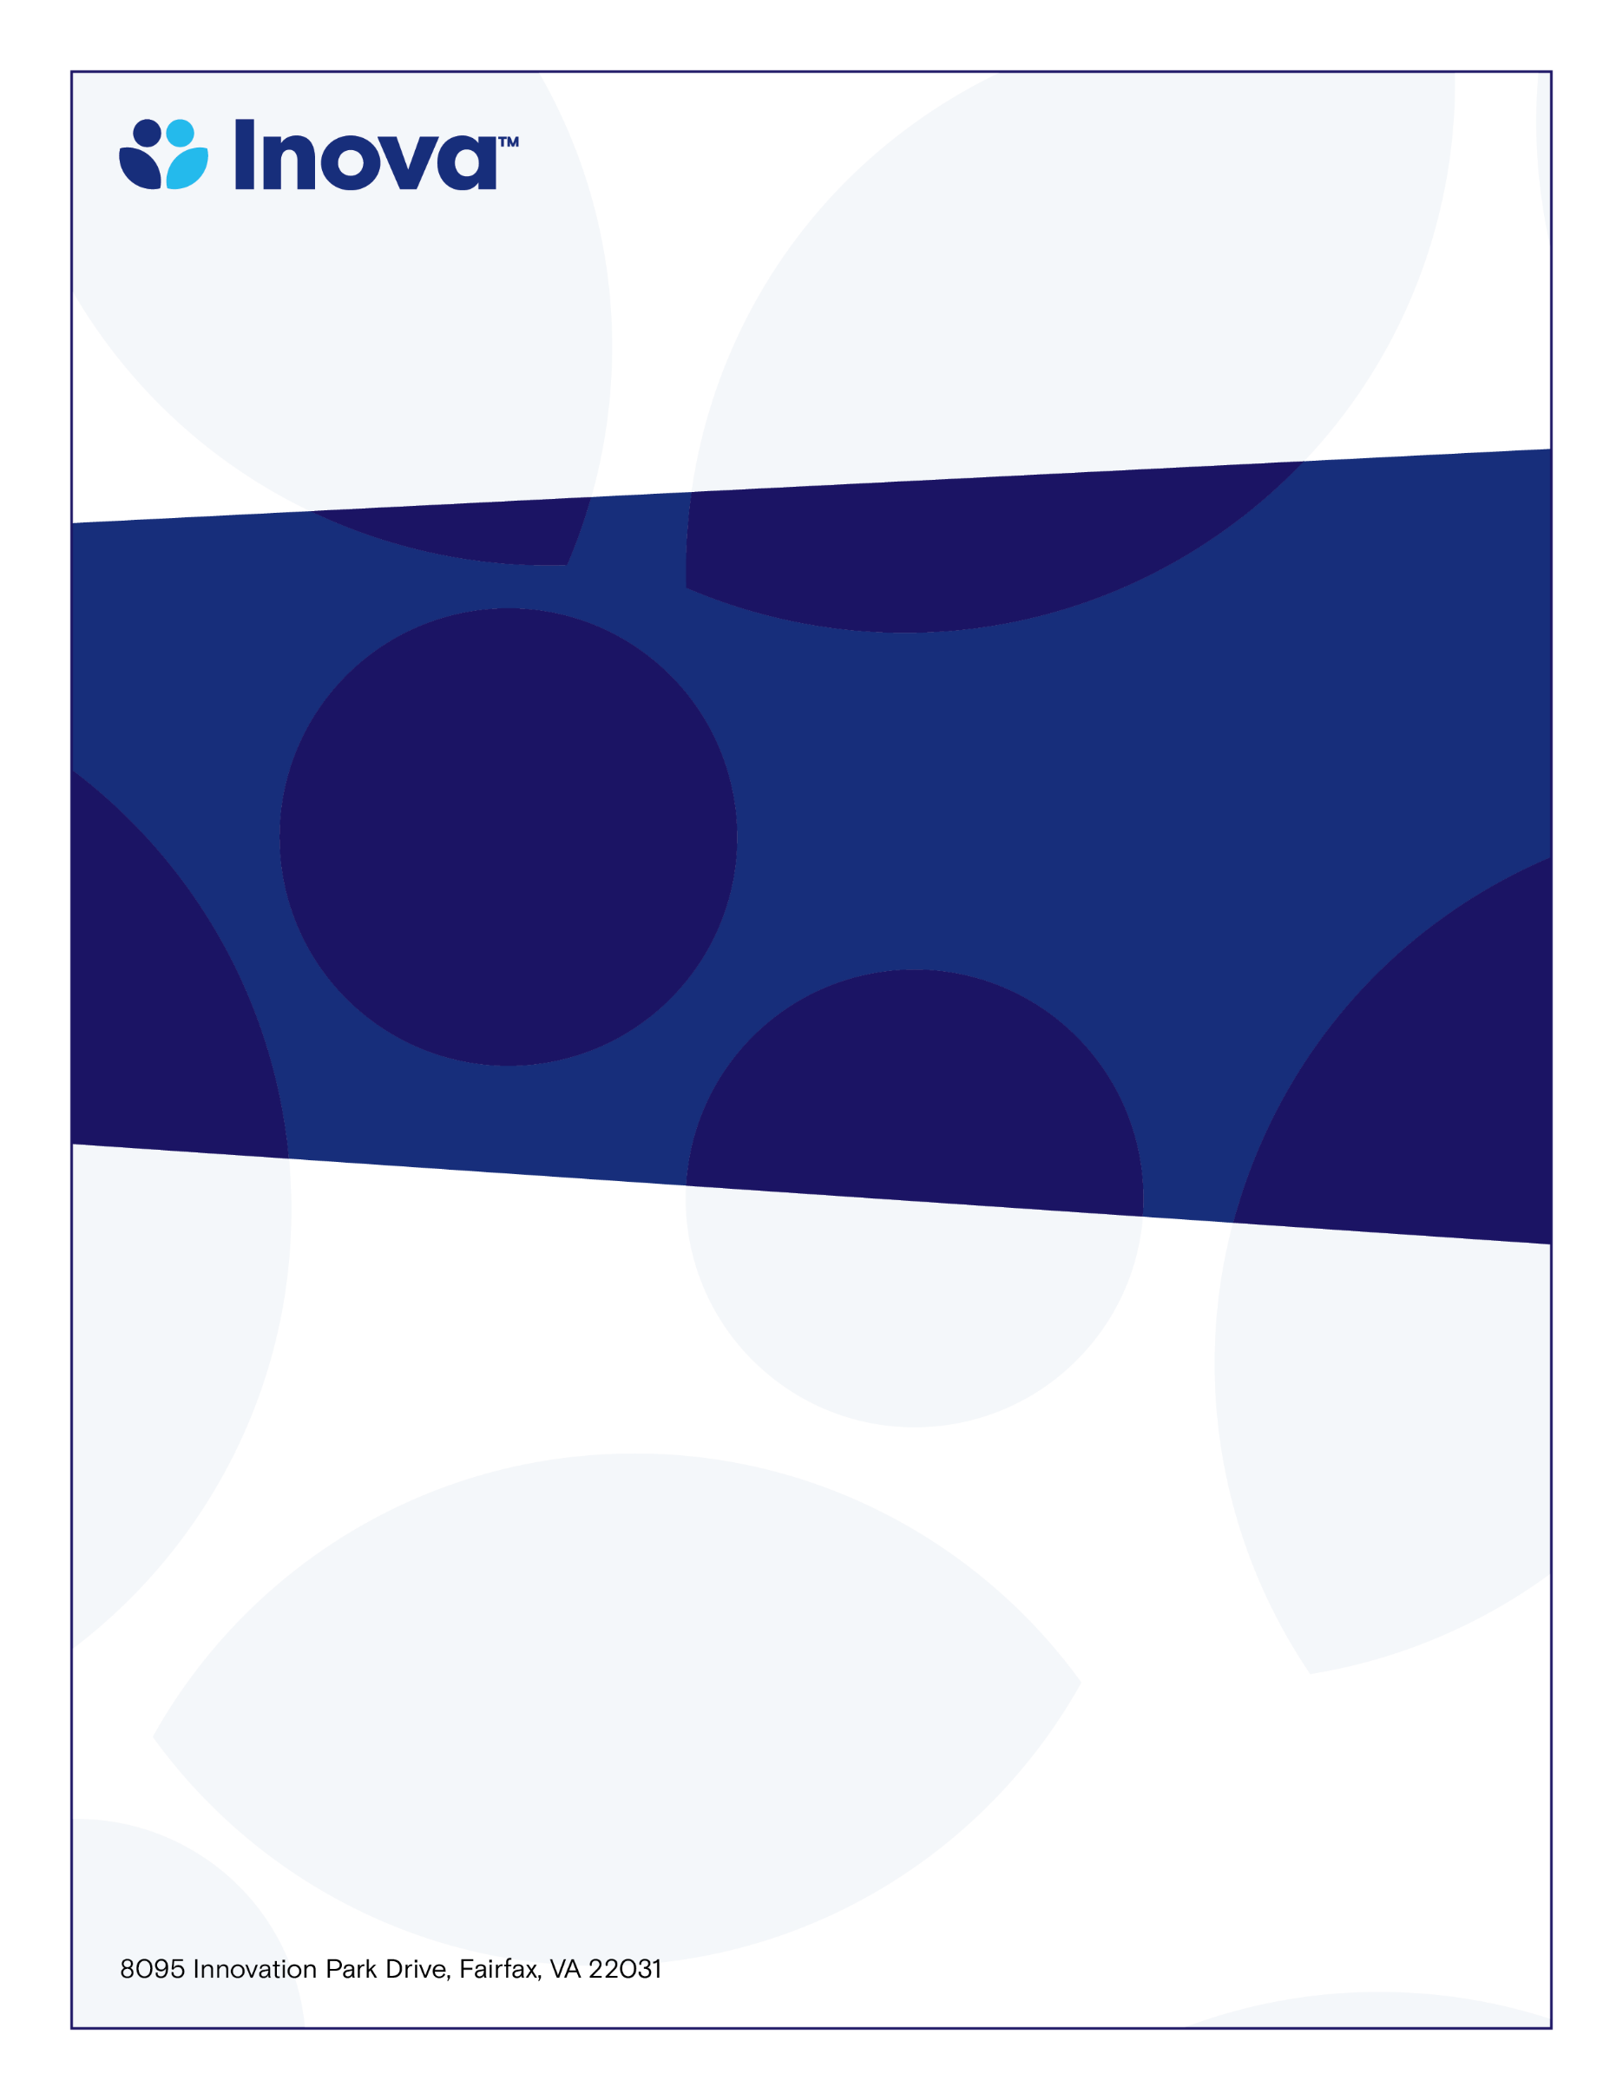

**IFH CME Neuro Cancer Tumor Board Conference**

**System Cancer Registry Department**

**Neurological Cancer Patient Multi-D Discussion**

Program Directors;

Mateo Ziu, MD & Adam Cohen MD

**Tuesday, March 19, 2024**

**4:00-5:00PM**

**www.oncolens.com**

**Learning Objectives**

* **Discuss management options for the treatment of the newly diagnosed or recurrent Neuro Oncology patient.**

**Target Audience**

* **Physicians and Allied Health**
* **Professionals with an interest in Oncology**

**To claim credit, text code QAXPUY** **to 703-260-9391**

**Accreditation:** The Inova Office of Continuing Medical Educations is accredited by the Medical Society of Virginia to provide continuing medical education for physicians.

**Credit Designation:** The Inova Office of Continuing Medical Education designates this live educational activity for a maximum of 0.75 AMA PRA Category 1 Credit(s)™. Physicians should only claim credit commensurate with the extent of their participation in the activity. Physicians may claim up to 1.0 credit in Type 1 CME on the Virginia Board of Medicine Continued Competency and Assessment Form required for renewal of an active medical license in Virginia.