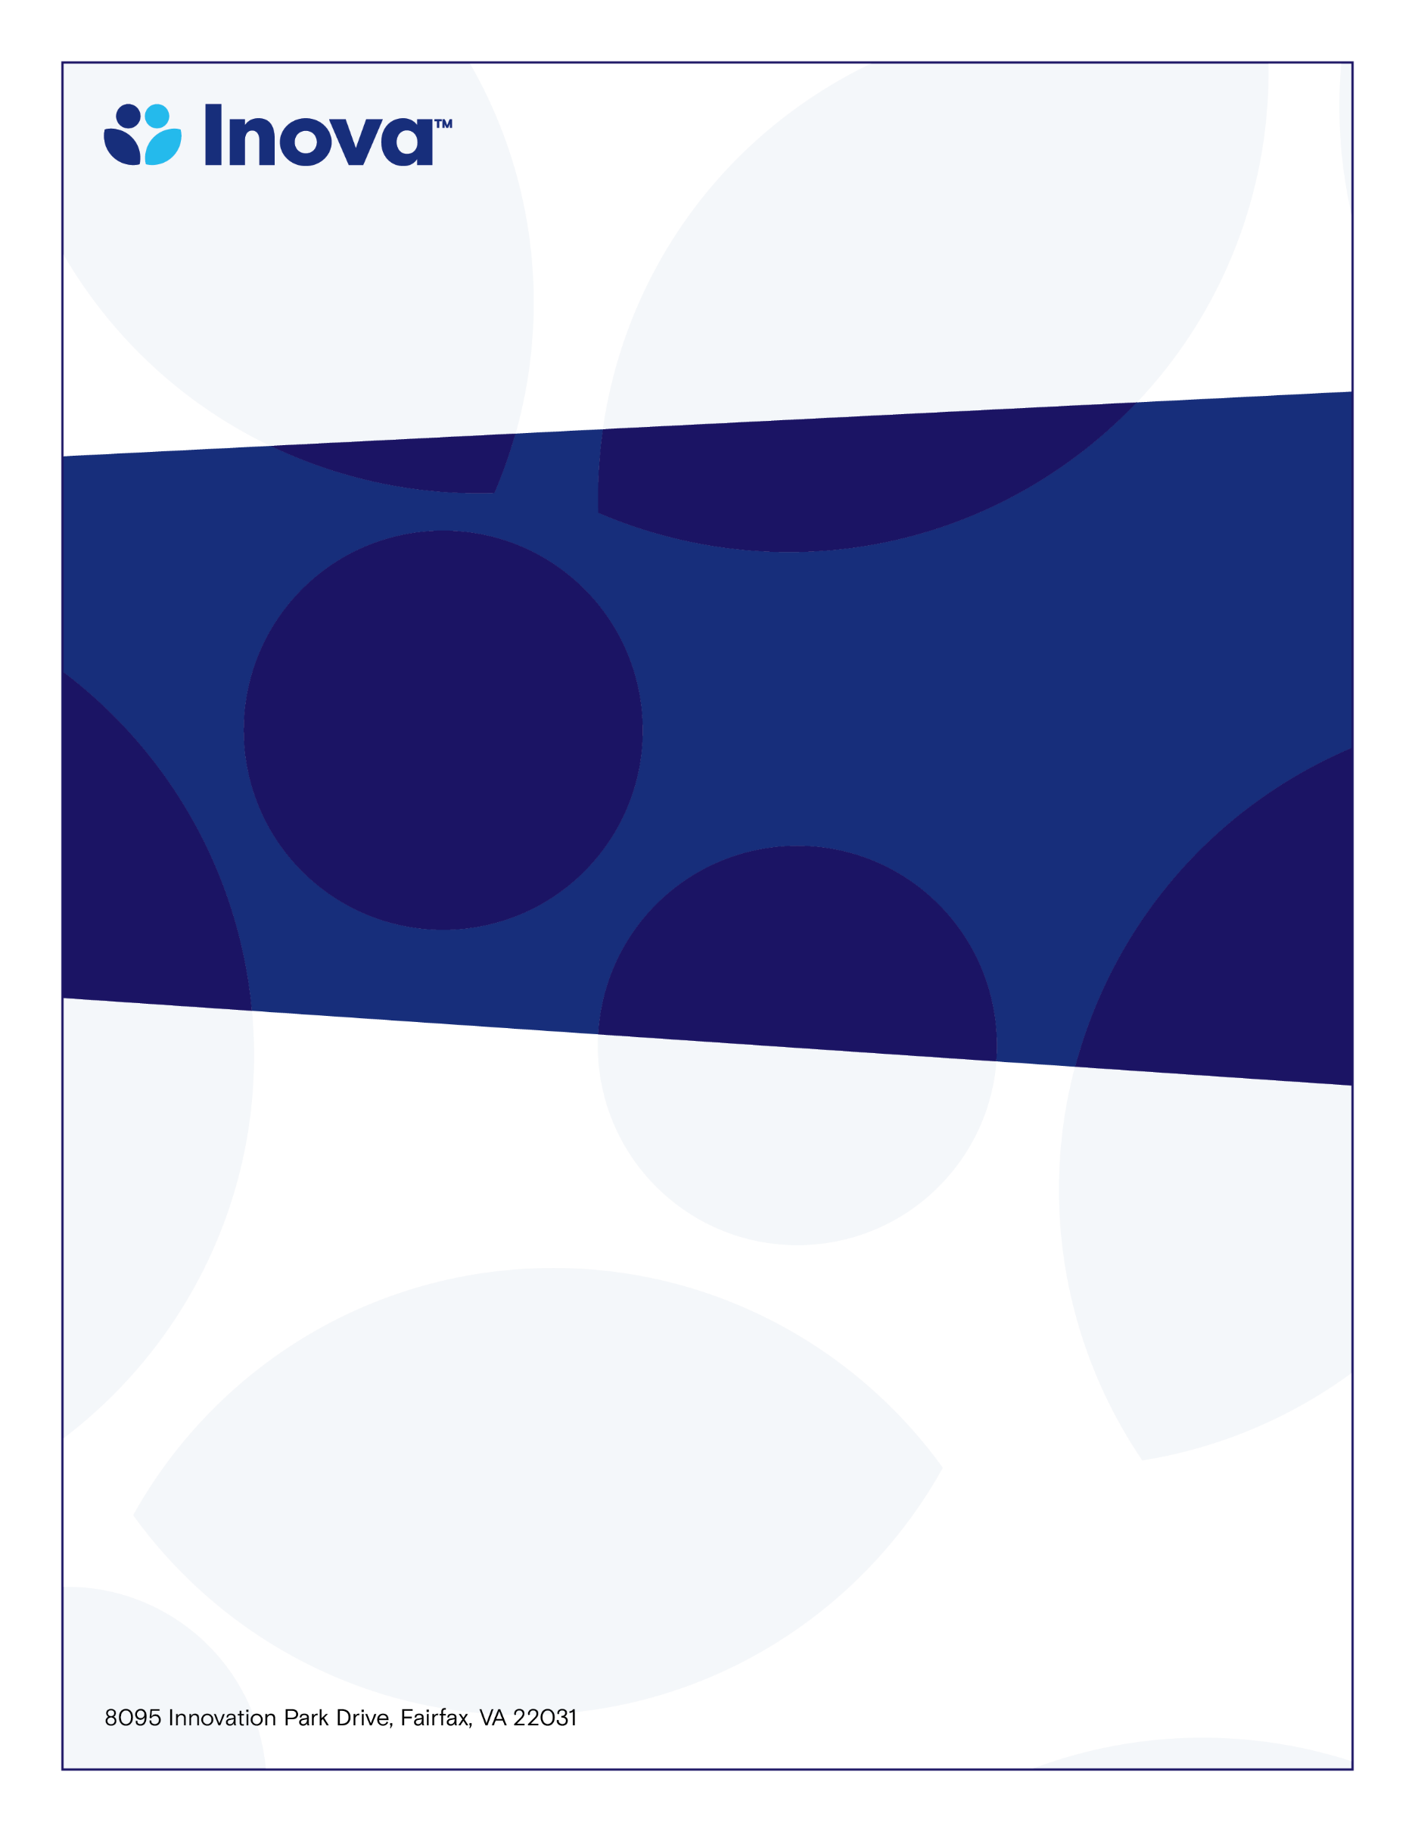

**IFH Hematology Oncology Tumor Board**

**System Cancer Registry Department**

# **Inova Fairfax CME Hematologic Malignancy**

**Multi-D Conference**

**Program Director; Danielle Shafer, MD.**

**Friday, March 15, 2024**

**7:30-8:30am**

**www.oncolens.com**

**Learning Objectives**

* **Review challenging Hematologic Malignancy cases in a Multidisciplinary forum**
* **Review new treatment strategies in Hematologic Malignancies**
* **Reinforce standard of care for Leukemia & Lymphoma therapies**

**Target Audience**

* **Physicians and Allied Health Professionals**

**with an interest in Oncology**

**To claim credit, text code PEVGOB to 703-260-9391**

**Accreditation: The Inova Office of Continuing Medical Educations is accredited by the Medical Society of Virginia to provide continuing medical education for physicians.**

**Credit Designation: The Inova Office of Continuing Medical Education designates this live educational activity for a maximum of 1.0 AMA PRA Category 1 Credit(s)™. Physicians should only claim credit commensurate with the extent of their participation in the activity. Physicians may claim up to 1.0 credit in Type 1 CME on the Virginia Board of Medicine Continued Competency and Assessment Form required for renewal of an active medical license in Virginia.**