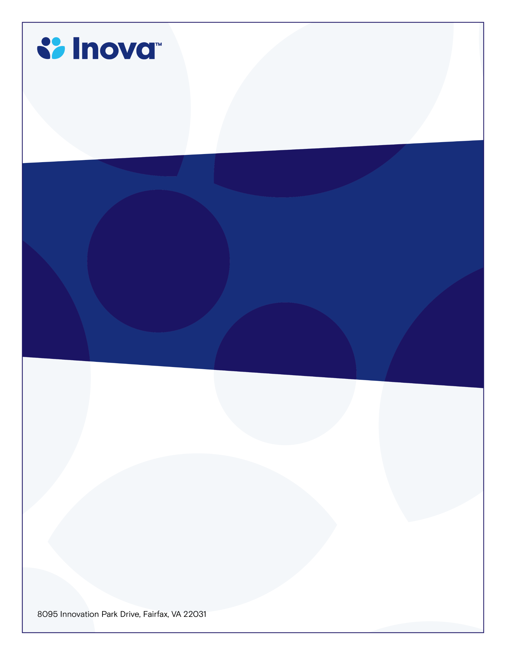

### **IFOH/IFH CME GI Oncology Tumor Board Conference**

**System Cancer Registry Department**

**Cancer Patient Case Presentations**

**Program Director; Wadlow, Raymond MD**

**Wednesday, March 20, 2024**

**7:00-8:00am**

**www.oncolens.com**

**Learning Objectives**

* **Identify current chemotherapy, radiation, and surgical guidelines to provide optimal care to the colorectal cancer population.**
* **Discuss the treatment and management options for pre- and post-surgical colorectal cancer patients.**
* **Review and discuss pathological findings to include special stains, gene mutations, and differential. diagnoses**

**Target Audience**

* **Physicians and Allied Healthcare**
* **Professionals with an Interest in Oncology**

**To claim credit, text code HOPDAQ to 703-260-9391**

**Accreditation:** The Inova Office of Continuing Medical Educations is accredited by the Medical Society of Virginia to provide continuing medical education for physicians.

**Credit Designation:** The Inova Office of Continuing Medical Education designates this live educational activity for a maximum of 1.0 AMA PRA Category 1 Credit(s)™. Physicians should only claim credit commensurate with the extent of their participation in the activity. Physicians may claim up to 1.0 credit in Type 1 CME on the Virginia Board of Medicine Continued Competency and Assessment Form required for renewal of an active medical license in Virginia.