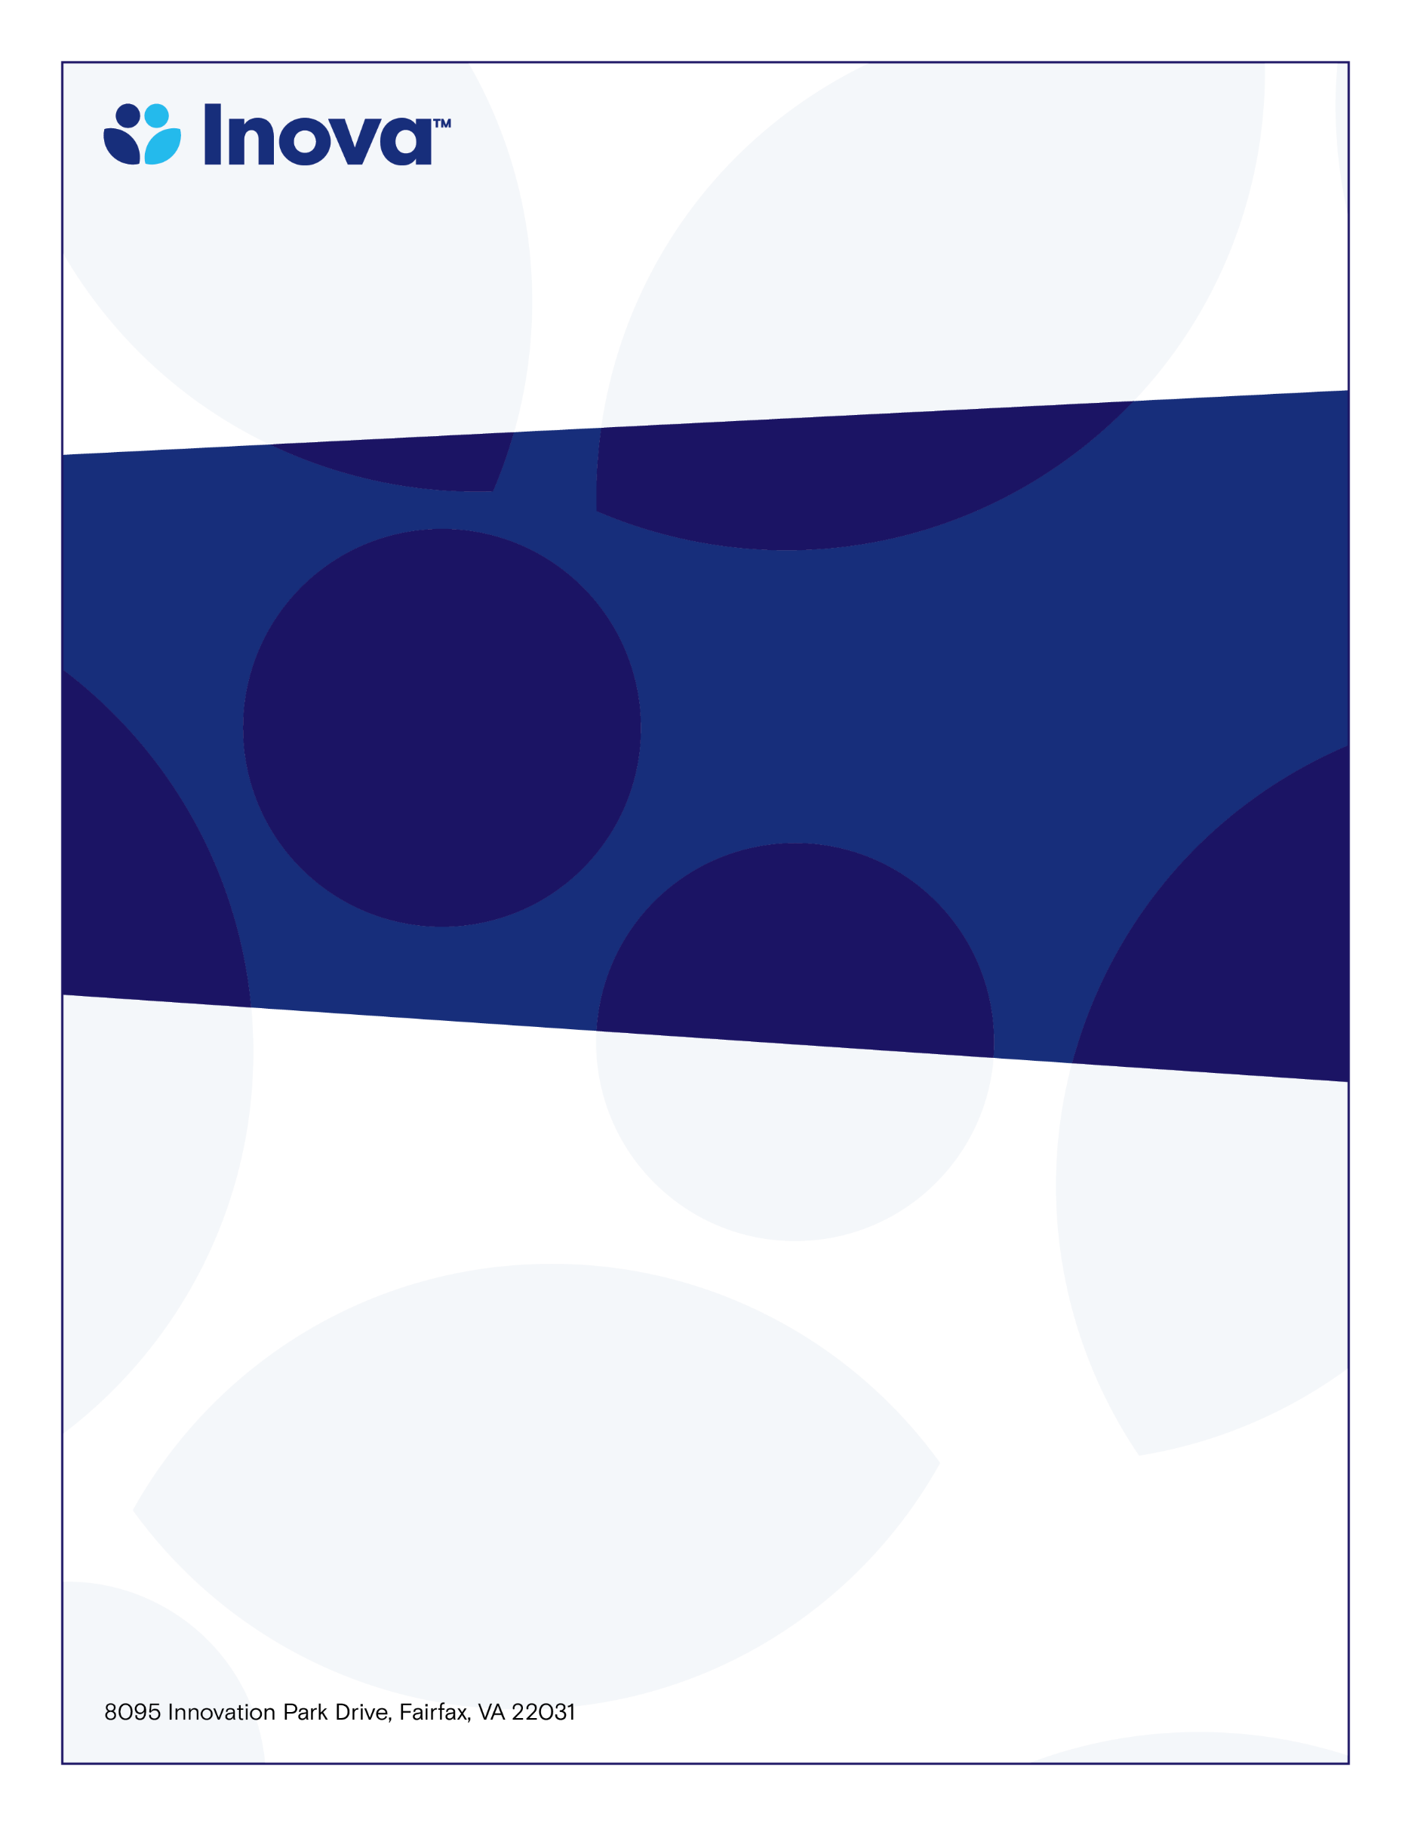

**IFH CME Sarcoma Cancer Case Conference**

**System Cancer Registry Department**

**Inova Fairfax CME Sarcoma Cancer Case Conference**

**Program Director;** [**Felasfa M. Wodajo MD**](http://inovanet.net.inova.org/Physicians/Details.aspx?sid=1&physician=2322)

**Wednesday, February 7, 2024**

**12:30-1:00PM**

**www.oncolens.com**

**Learning Objectives**

* **Identify current chemotherapy, radiation, and surgical guidelines to provide optimal care to the Sarcoma population**
* **Discuss the treatment and management options for pre- and post-surgical Sarcoma Cancer patients**
* **Review and discuss pathological findings to include special stains, gene mutations, and differential diagnoses**

**Target Audience**

**Physicians & Allied Health Professionals**

**with an Interest in Oncology**

**To claim credit, text code MUNSUG to 703-260-9391**

**Accreditation:** The Inova Office of Continuing Medical Educations is accredited by the Medical Society of Virginia to provide continuing medical education for physicians.

**Credit Designation:** The Inova Office of Continuing Medical Education designates this live educational activity for a maximum of 1.0 AMA PRA Category 0.5 Credit(s)™. Physicians should only claim credit commensurate with the extent of their participation in the activity. Physicians may claim up to 1.0 credit in Type 1 CME on the Virginia Board of Medicine Continued Competency and Assessment Form required for renewal of an active medical license in Virginia.