IFMC Foot and Ankle Surgery/Podiatric Section Grand Rounds

**Accreditation:** The Inova Office of Continuing Medical Educations is accredited by the Medical Society of Virginia to provide continuing medical education for physicians.

Inova Fairfax Medical Campus Department of Orthopaedic Surgery

**Target Audience:**

**Physicians, Residents, Students and APPs**

**SMS Code for CME Credit:**

**KELYEN**

Wednesday, June 14, 2023 at 6:15am

**Conference Rooms D, E + F *(above the old cafeteria)***

<https://inova.zoom.us/j/93900157213?pwd=SGRPRTFsbVJzTDZkTnRBeVk2YnVpdz09>

**Minimally Invasive Surgery**

**David Siegel, DPM**

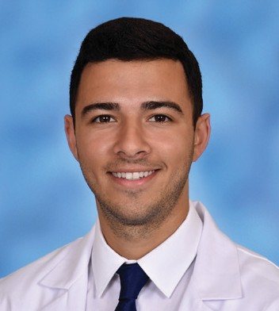



**Minimally Invasive Surgery**

**Kyle Miller, DPM**

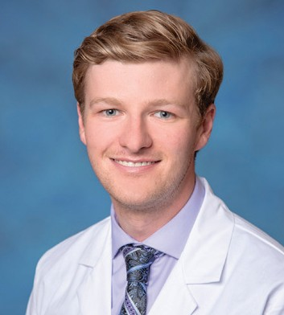

**Learning Objectives:**

* Discuss minimally invasive surgery current concepts
* Examine pros and cons
* Explain patient selection
* Review procedures specific to bunion deformity and hammertoe repair

**Learning Objectives:**

* Understanding minimally invasive techniques related to midfoot and hindfoot charcot reconstruction
* Discuss MIS calcaneal osteotomies with calcaneal varus/valgus malalignment
* Understand arthroscopic techniques beyond traditional uses

**Credit Designation:** The Inova Office of Continuing Medical Education designates this live educational activity for a maximum of 1.0 AMA PRA Category 1 Credit(s)™. Physicians should only claim credit commensurate with the extent of their participation in the activity. Physicians may claim up to 1.0 credit in Type 1 CME on the Virginia Board of Medicine Continued Competency and Assessment Form required for renewal of an active medical license in Virginia.