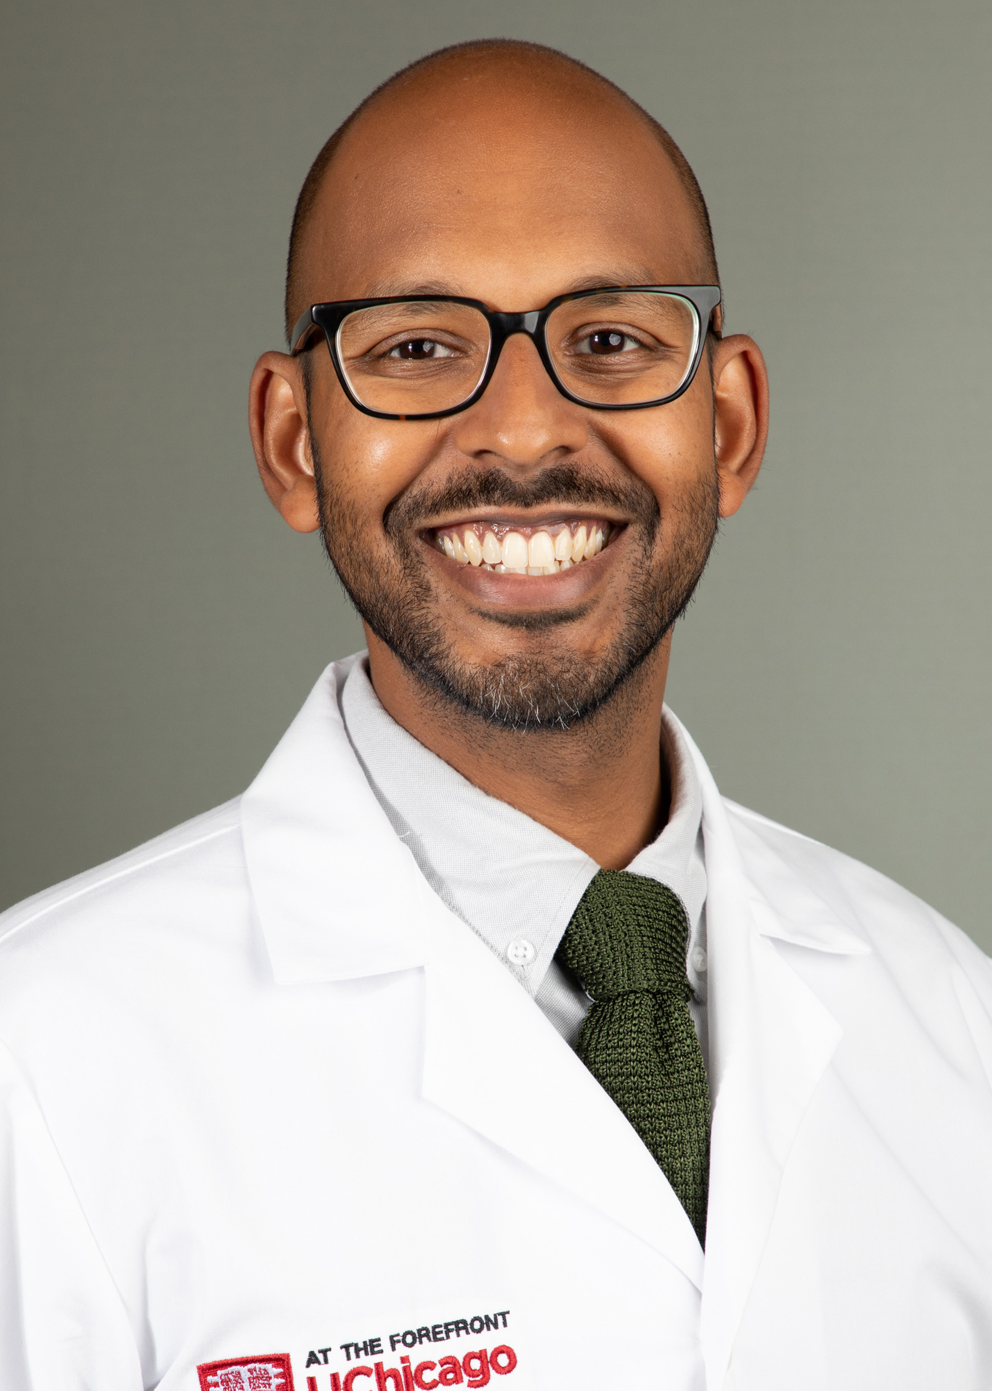
Women’s Service Line Grand Rounds
Department of Obstetrics & Gynecology
Monday, April 3, 2023
8:00 AM – 9:00 AM
Location: PCC Auditorium
Breakfast Available Prior to Grand rounds

Learning Objectives:
- Understand the epidemiology of HIV and HIV-related risk behaviors among pregnant people
- Evaluate data surrounding missed opportunities for initiating preexposure prophylaxis (PrEP) during reproductive health visits
- Discuss new recommendations from the Centers of Disease Control and the American College of Obstetricians and Gynecologist regarding PrEP counseling and initiation

Target Audience:
Physicians, Fellows, Residents, Nursing Staff and Allied Health Professional
Zoom link for those unable to attend in person:
Meeting URL: | https://inova.zoom.us/j/94190038420
Meeting ID: | 941 9003 8420

“The Risk of HIV Acquisition Among Pregnant People: A Neglected Opportunity for PrEP”
Ashish Premkuma, MD

Upcoming OBGYN Grand Rounds
April 24, 2023
Dr. Babb– New Frontiers in Carrier Screening

Accreditation: The Inova Office of Continuing Medical Educations is accredited by the Medical Society of Virginia to provide continuing medical education for physicians.

Credit Designation: The Inova Office of Continuing Medical Education designates this live educational activity for a maximum of 1.0 AMA PRA Category 1 Credit(s)™. Physicians should only claim credit commensurate with the extent of their participation in the activity. Physicians may claim up to 1.0 credit in Type 1 CME on the Virginia Board of Medicine Continued Competency and Assessment Form required for renewal of an active medical license in Virginia.

